

Faculty of Engineering and Technology
Electrical and Computer Engineering Department
Designing of 36V 20A Power Supply

Name: | ID:

Instructor:

TA:

Section:

Date:

1

Table of Contents:

1) | Abstract: ...................................................................................................... | 3
2) | Theory: ........................................................................................................ | 5
3) | Calculations & Simulations & Discussions: .................................................... | 7
 | Stage1: Input and output waveforms of the transformer: .......................................... | 7
 | Stage2: Full-Wave Bridge Rectifier: ........................................................................ | 8
Stage 3: Capacitor Smoothing.................................................................................... |  | 9
 | Stage 4: Regulator: ................................................................................................ | 10
 | Stage 5: Load: ....................................................................................................... | 11
4) | Conclusion:.......................................................................................................... | 13
5) | Reference: .................................................................................................. | 13

2

- Abstract:

In this assignment we will use Orcad Pspice to design a power supply and simulate single phase full wave rectifier that converts the AC voltage 220Vrms and current to DC voltage and current [36 Volt & 20 Ampere] and we will design some parameters for the step down transformer and we will calculate the attenuation in ripple from the results we get from Orcad Pspice.

3

- Theory:

Nowadays power supplies are most important and crucial things and used widely in different applications starting fron general purpose computer to complex machines.The important function of these supplies is the rectification.As we know that the conversion of AC to DC is called rectification.The below diagram gives information about the steps involved in conversion for AC to DC. The below five steps briefly explain the function of each step.

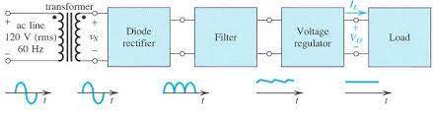

Figure 1-Block Diagram of Rectification-

The above picture shows the overall block diagram and process of the AC to DC conversion as it starts and completes in the below steps.

Step 1:
In the first step the Ac supply which is 220v is used to give input voltage at the terminals of the transormer and after that the transformer will stepdown that voltage.
Step 2:
In this step we use bridge rectifier which converts the step downed AC volatge to DC volatge after it is not complete DC voltage still it has some ripples in it.
Step 3:
Thirdly this rippled DC voltage is applied to the capacitor where its ripples are removed.Bigger the capacitor the lower the ripples will be.So for that we use the bigger capacitor like 3000uF.
Step 4:
In next step the the regulator is used to stabilize this volatge and for that we can use the commercilly build regulators like lm317 or we can bulid it from the OPAMP also.
Step 5:
In the last step we use the capacitor for final stage and load and also we willuse some power transistor to enhance the current of the power supply.

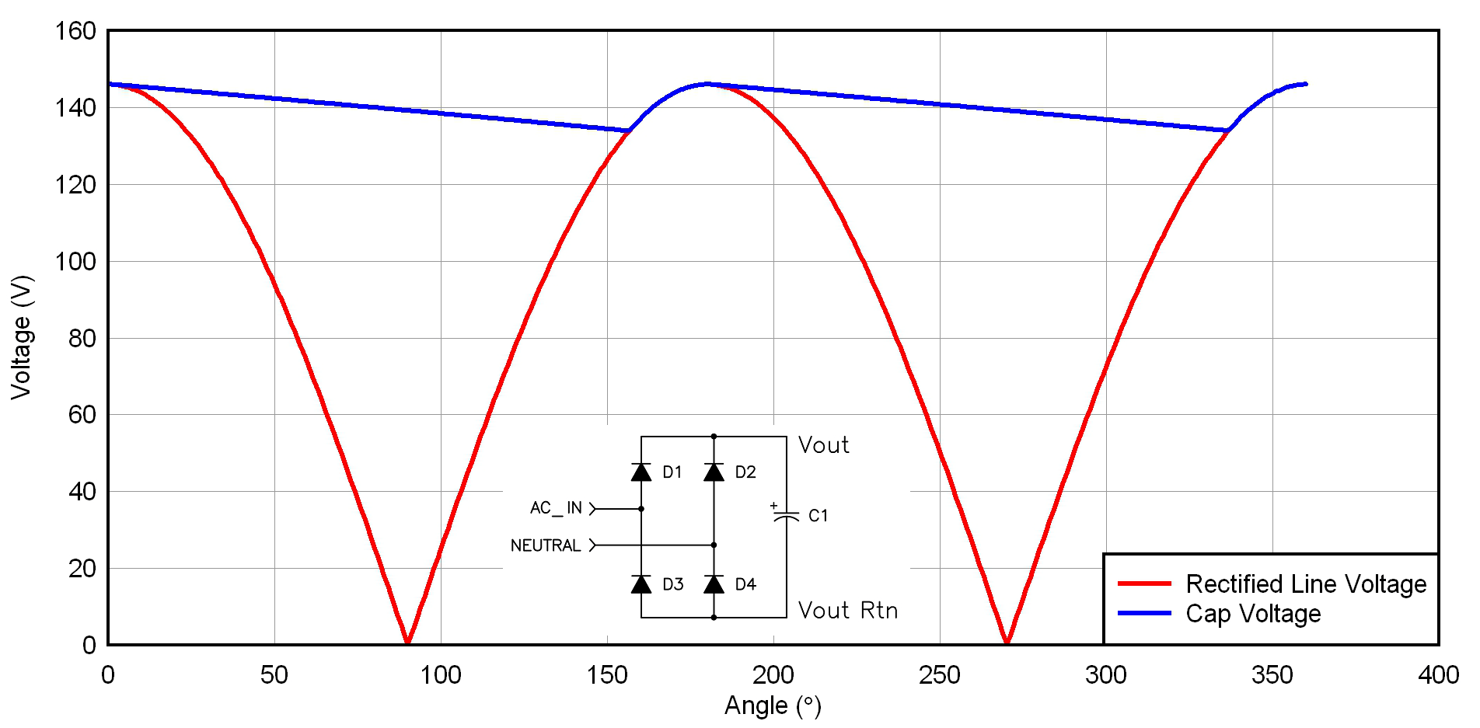
Figure 1-Smoothed Output-

If we look at the output after we use a DC filter (Capacitor Smoothing), we notice that the output have a small amount of ripple.
So, because the output still contains a ripple, we must use a linear regulator to remove the ripple.There are many types of regulators can be used as for 12V 7812 or for 5V the 7805 is used. If we want to gain variable volatge then lm317 is used.
The linear regulator is a system that used to remove the ac component (ripple) at the output to get a steady voltage (pure DC output).


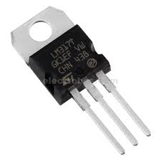

Figure 2-Linear VRegulator-

The figure below shows the system and components of linear regulator.


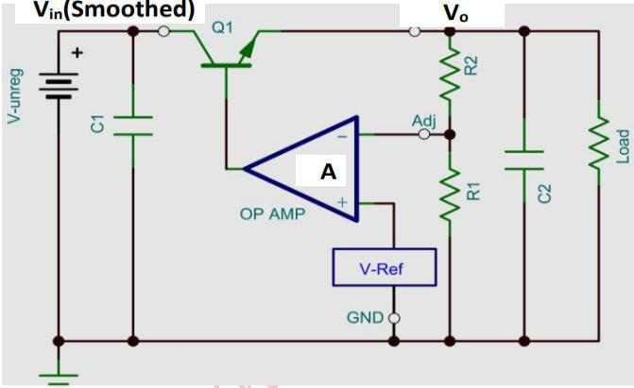

Figure 9-Linear Regulator-

The above pic is the internal diagram of the regulator as it conatins theop amp
for comparing the volatges and a transistor for the switching of the volatge and a zener diode for giving reference voltage.And it also contains the two resistors made volatge divider for the controlling of the output volatge to which we have to regulate our output.

The below figure shows the output voltage after we use a regulator to remove the ripple. This pic is taken from simulation.

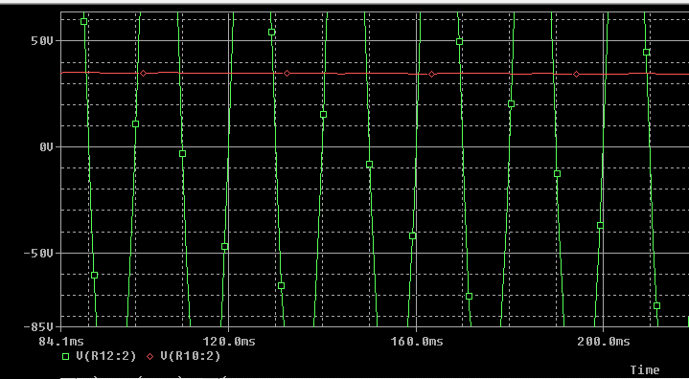

In the above fig we can see that the output voltage is pure dc as comapred to applied AC voltage 220V. The input volatge was in the Sin wave.

3) Calculations & Simulations & Discussions:

Stage1: Input and output waveforms of the transformer:

As single phase volatge is applied across the transformer and this is 220v AC and on output the AC waveform will be obtained but it will be step downed.So on the output of transformer 36v Ac will be obtained and the claculation for this is that.
As we know that
Vp/Vs= Sqrt (L1/L2)
As in our case the Vp =220v and Vs=36
So putting these values
220/36= sqrt(L1/L2)
6.11=sqrt(L1/L2)
37.34=L1/L2
Let the value of the L2 10mH so the value of the L1 will be
37.34*L2=L1
37.34*10mH=L1
370.34mH=L1
So by these two values will be saved in transformer with coupling factor with 1.0

Simulation for Stage 1:

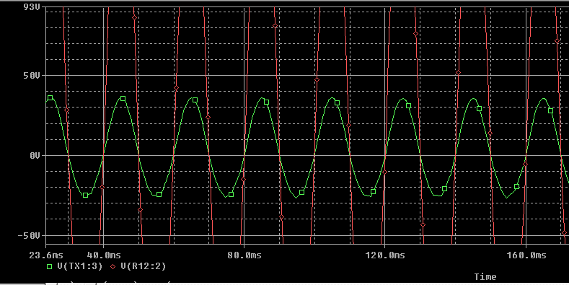



Stage2: Full-Wave Rectifiers Output

The step downed volatge from the transformer is fed into the bridge recifier and the work of the bridge rectifier to convert the AC voltage to the DC voltage and this DC volatge will be done smooth in next stage.

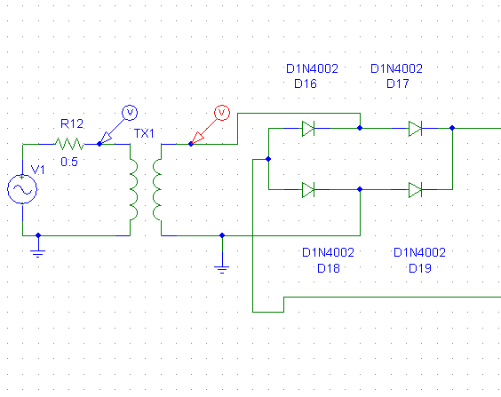
These four diodes are the resonsible for the conversion of AC voltage into the DC.In our case we have used the 1N4007 diodes for the formation of the bridge rectifier.On two sides the AC volage is applied and on other two sides the DC output voltage is taken.

The output of the stage is given in the below fig:

Simulation of Stage 2:
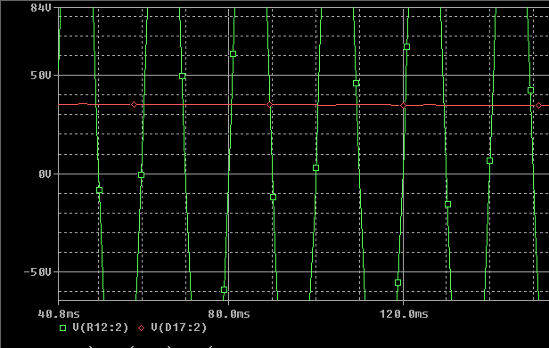

In the above pic we can see that the output volatge is approximately 36V and this has some ripples in it and we will do them smooth via capacitor.

Stage 3: Capacitor Smoothing

  - R(Load)=V/I=36Volt/20Ampere=1.8 ohm

  - If we take ΔV=25 Volt
ΔV=I/(6*C*f) → 25=20/(6*C*50) → C=2666uF

Choose C=3000uF

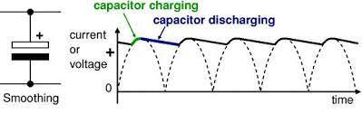

The pic shows the importance of the capacitor as bigger the capacitor lower it will be charged and smaller will be the ripples in it. So small ripples means the effective filtering has been done for same capacitor and resistor as compared to the half wave.
As the formula indicates that
r=Vrpp/Vdc
so formula indicates that r is the effectiveness of filter and leeser the r the more effective will be the filteration.So to lower the r we have to increase the capacitor or increase the load resistance.

Simulation of Stage 3:

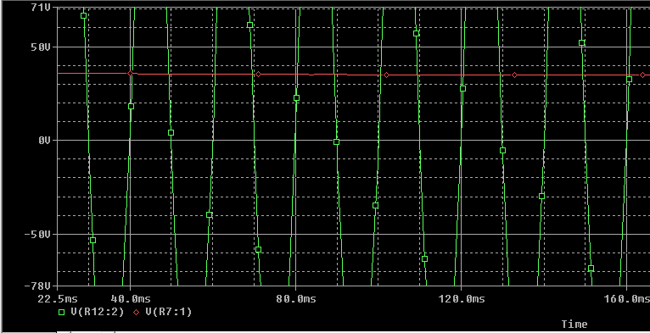

In this stage we use a dc filter (Capacitor Smoothing) to reduce the ripple at the output, but this filter cannot eliminate all ripple at the output, so we will use in the next stage a regulator to get a pure dc voltage.

Stage 4: Regulator:

In this step a zener diode is used whose voltage is 5.1V so

Vout= Vin *(1+R2/R1)
36 =5.1(1+R2/R1)
7.05=1+R2/R1
6.05=R2/R1
Let R1=5K
6.05*R1=R2
6.05*5k=R2
30.25k=R2
So R1=5K and R2=30.25k

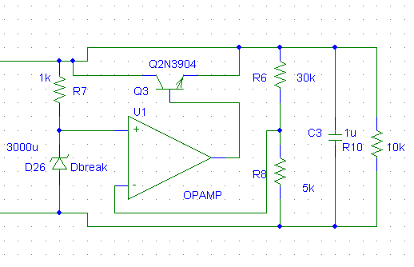

So this stage is working as the regulaor as opamp is used in it as a comparator to compare two output voltage level.And the calculated above values of the resistors are responsible for the output at the final resistor.
In this circuit the transistor is used for the switching and the other resistor is used for the making voltage divider between zener diode and that resistor.

Stage 5: Load:
After the regulator the load section is present as on this load thethe waveform which is shown below is generated.And the output is 36v dc pure as it was expected from the beginning.

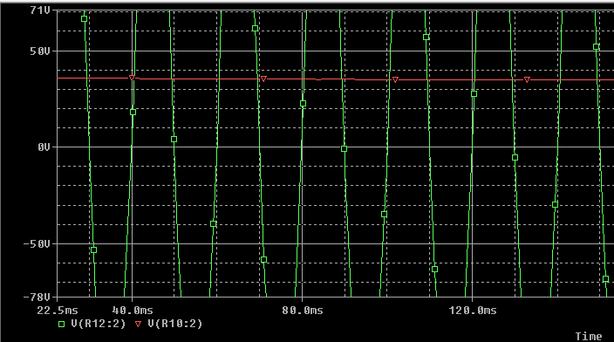

To calculate the attenuation in ripple →
Ripple=Vcmax-Vcmin
=36.863-35.036
=1.827 Volt

4 0 | V
 |  |  |  | (17.277m,36.863)
 |  |  |  |  | (18.864m,35.036)
3 0 | V
2 0 | V
1 0 | V
0 | V
 | 0 s | 5 m s | 1 0 m s | 1 5 m s | 2 0 m s | 2 5 m s | 3 0 m s | 3 5 m s | 4 0 m s | 4 5 m s | 5 0 m s
 |  | V ( C 1 - N o o r T e e t i : 2 , C 1 - N o o r T e e t i : 1 )
 |  |  |  |  |  | T i m e
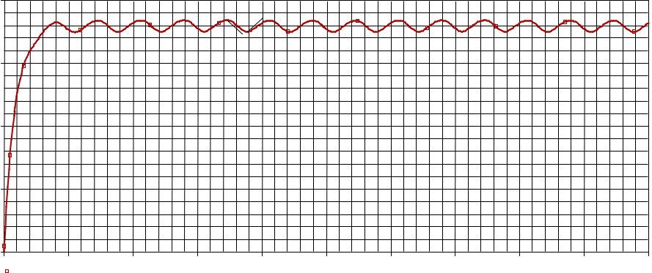

Figure 32-Output Voltage of the Capacitor (C1-NoorTeeti) at Stage 3-
from output graph Ripple =0 Volt
attenuation in ripple= 1.827-0= 1.827 Volt

Final Circuit Connection:
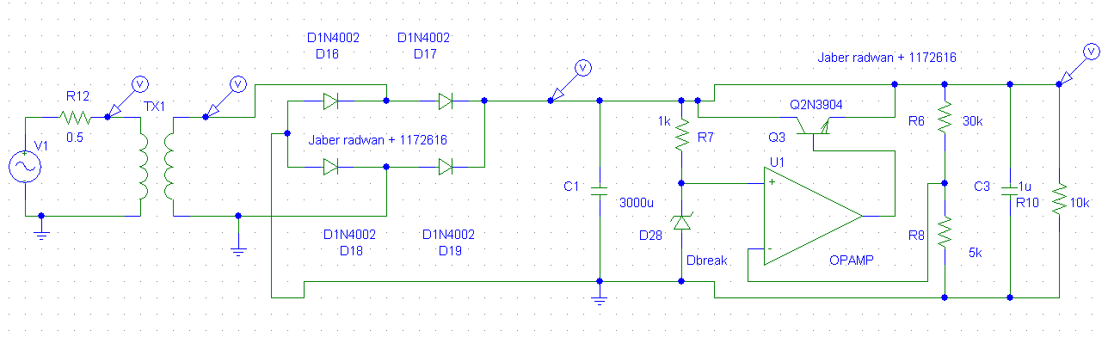

Conclusion:
So we can conclude that by above model we can make the powe supply of any voltage as 5v ,12v ,24v, 36v or 48v.Also we can change components according to our desire that we can change the volatge regulator as use the commercial built in like 7805,7812 or lm317 and in the presence of these there is no need to use opamp and transistor etc.similarly by changing capacitors and transformer rating or turns ratio our resired volatge can be obtained. Overall , the above model is flexible and can be changed accoringly.

  - Reference:

- Power Electronics EE 3305 Lecture Notes, Dr. Muhammad Abu-Khaizaran.

- Muhammad Rashid, “Power Electronics: Circuits, Devices and Applications”, 4 th ed. Prentice Hall, 2013.

20

